AI Camera 2.0 Basic Projects

Lesson 1: Gesture-Controlled Car
Ages: 12 and up
Duration: 45 minutes

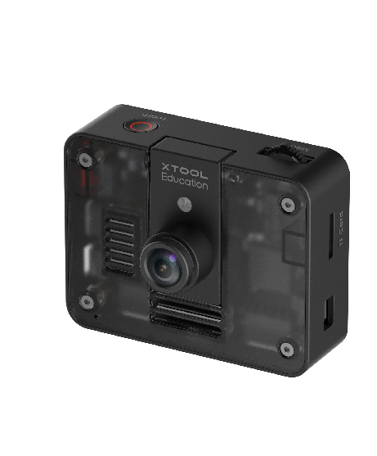

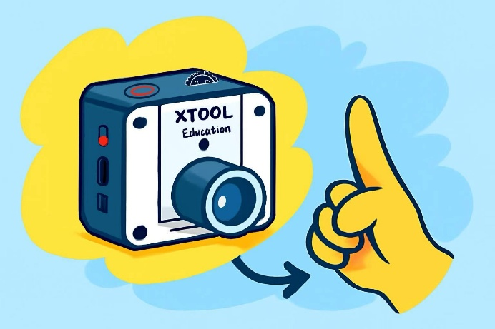
Objectives:
By the end of class, students will be able to:
- Understand the basic principle of gesture recognition
- Identify real-world applications of AI and computer vision
- Grasp core programming concepts: events and conditions

Overview
This course introduces students to the fascinating world of artificial intelligence by exploring gesture recognition technology to control an mBot2 robot. Designed to inspire interest in programming and robotics, the session provides a hands-on experience where students connect hardware components and use block-based programming to successfully control the robot through custom hand gestures. By the end of the class, each student will have created a functional, demonstrable project and gained a fundamental understanding of computer vision principles.

Pre-lesson Checklist
For the teacher:
- Computer with mBlock installed and tested;
- Adequate number of mBot2 robots (fully charged);
- AI Cameras compatible with mBot2;
- CyberPi and connection cables;
For the students:
- Computer with mBlock installed and ready;
- mBot2 robot and AI camera set per group;
- CyberPi and connection cable;
- Workspace cleared for testing and experimentation;

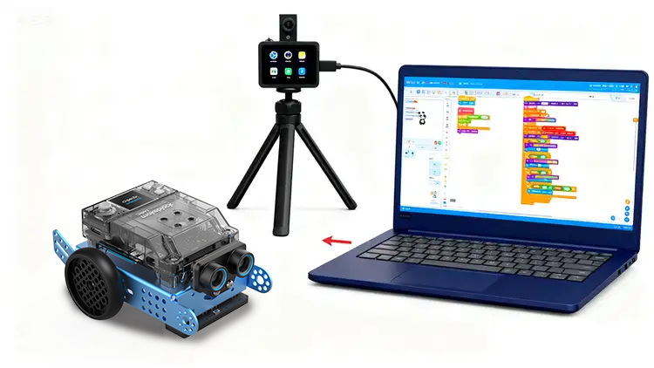

Agenda (45minutes)
Duration | Content
5 minutes | Section 1 - Introduction  - Demonstrate controlling the car through gestures;  - Prompt interaction: “What does this resemble?”
10 minutes | Section 2 - Explore  - Explain computer vision through a vivid metaphor;  - Talk about how the AI actually “learns” to recognize gestures;  - Define the meaning of recognition results and confidence;
15 minutes | Section 3 - Create and practice  - Set up the programming environment and activate gesture recognition;  - Recognize gestures and display the results;  - Program gesture-controlled actions;
10 minutes | Section 4 - Presentation  - Invite 2-3 groups of students to demonstrate their creative gesture controls;  - Compare and talk about the differences among their works;
5 minutes | Section 5 - Evaluate  - Review the problems they met and how they solved;  - Encourage thinking about other applications of this technology;

Activities

Section 1 - Introduction
In today’s lesson, we will explore the interactive mysteries between artificial intelligence and robotics, experiencing how to control the mBot2 smart car in real-time using the most intuitive method—gestures.
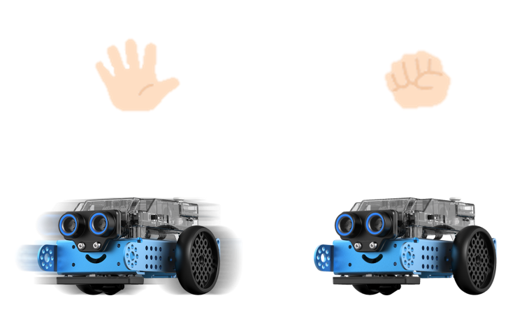
We will begin by understanding the fundamental principles of computer vision, learning how the AI camera mimics the human visual system to recognize different gestures. Then, each student will design a unique gesture-based command system, using block-based programming to establish logical connections between gestures and mechanical actions. Ultimately, we will achieve an intelligent control system that requires no remote controller or physical contact.

Section 2 - Explore
In this segment, students will deconstruct how artificial intelligence vision works through vivid metaphors and interactive demonstrations.
Step 1: Connecting human and AI vision. By asking the question, “How do we recognize an apple?” helping them relate AI’s functioning to human visual recognition.
Step 2: Watching how machines capture images. Students will observe the real-time preview feed from the AI camera in the programming software, allowing them to see what the AI “sees” and understand how visual data is captured.
Step 3: From learning to recognizing. The concept of an AI model as a trained program will be explained. The training process will be illustrated through the metaphor of teaching a young child.
Step 4: Testing and understanding results. Students will then make gestures and observe the software’s recognition results in real time. The meanings of the Label (the identified gesture) and Confidence (the accuracy percentage) will be explained, emphasizing that these represent the “brain’s” conclusion after analysis and judgment.

Section 3 – Create and practice
In this section, students will transition from theory to practice, working in small groups to hands-on build and program a unique gesture control system for their mBot2 car.
Task 1: Set up the programming environment and activate gesture recognition
Step 1: Set up the programming environment and activate gesture recognition. In the mBlock, click the [Extensions] button in the lower left corner, add the [AI Camera 2.0] and [mBot2 Shield] modules. This is like equipping our programming toolbox with two essential tools: “eyes” (the AI camera) and “hands and feet” (the car controller). | 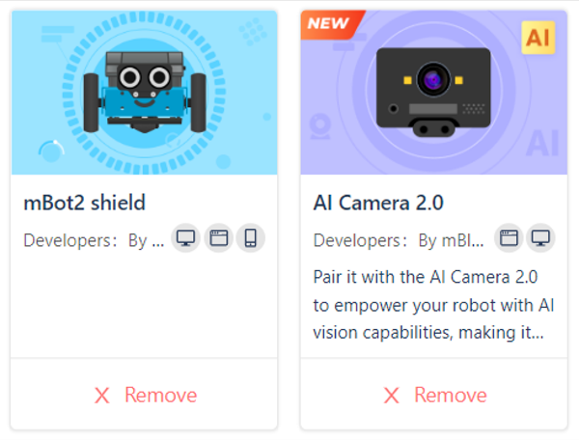
Step 2: Create and define a gesture recognition startup function. We will package the complex process of "activating gesture recognition" into a ready-to-use shortcut command called [Gesture Recognition Startup]. By simply calling this function, the AI camera can be quickly initialized and prepared for operation.  Step 3: Invoke the startup function and confirm successful initialization. [When CyberPi starts up] block will call the newly created module [Gesture Recognition Startup] and [Gesture_recognition]. After running the program, the text [Gesture_Cam_LAN] should appear on CyberPi’s screen. | 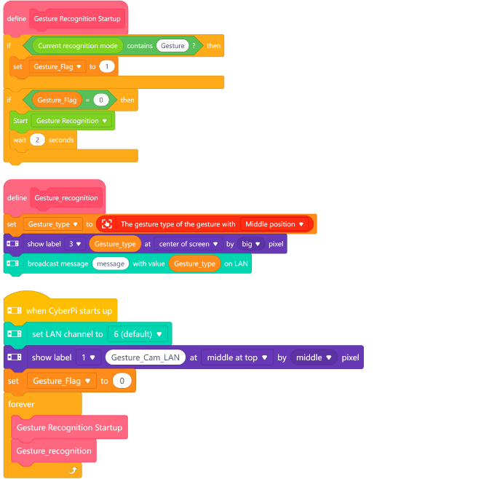

Task 2: Recognize gestures and display the results
Step 4: Create a "Received_value" variable. Think of this variable as a mailbox—the AI Camera will place recognized results (such as "fist" or "open palm") into this mailbox, allowing other parts of the program to retrieve and use the information. | 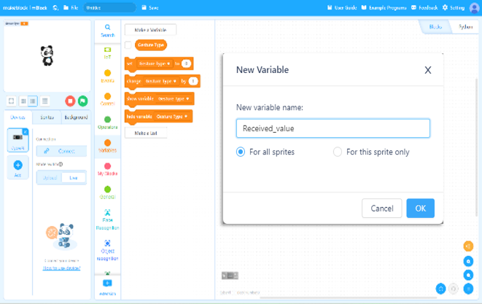
Step 5: Retrieve and display recognition results. Run the program and perform different gestures. Observe whether the text displayed on the screen matches your gestures. If recognition is inaccurate, guide students to adjust the distance and angle of their gestures in front of the camera. | 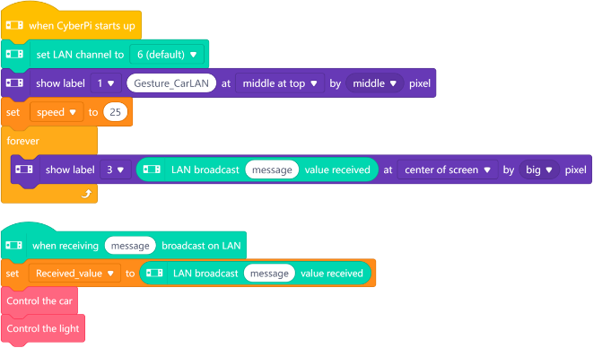

Task 3: Program gesture-controlled actions
Step 6: Build the control logic framework. Implement an infinite loop structure in the program to ensure the car continuously responds to gesture changes. Use [If-else] conditional logic blocks to construct branch logic.  Step 7: Implement multi-gesture mapping control. Run the program and test different gestures to observe the car’s reactions. | 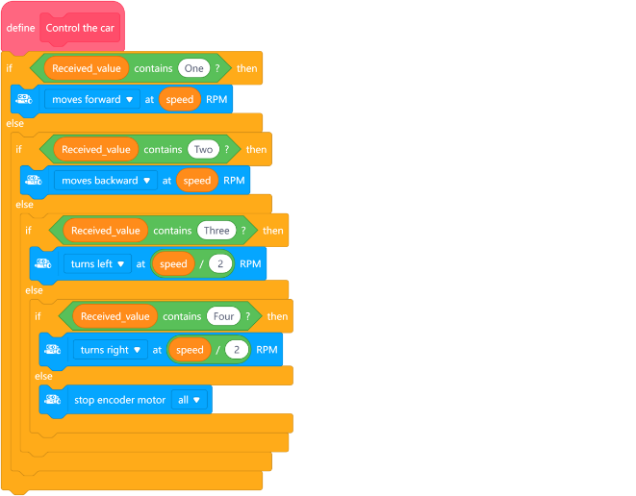

Section 4 - Presentation
In this session, students will show and compare their projects. During your demonstration, please have the students explain: What gesture commands did you design for the car, and why did you choose this design approach? What challenges did you encounter during the process?
After 2-3 groups have presented, the teacher will guide a whole-class discussion. Please observe carefully: What are the similarities and differences in their solutions? What is the smartest part of their designs? Secondly, if you were to upgrade your car to a 2.0 version, what ideas would you borrow from other groups’ designs?

Section 5 - Evaluate
Now let's review some key points in this lesson.
- What was the biggest challenge you faced in today's project? How did you and your team work together to solve it?
- Besides controlling a car, where else do you think gesture recognition technology could be used to help people or make life more fun?

